Water Source and Distance Analysis Report

DATAUPSKLL CONSULTING KENYA LIMITED
Project Evaluation Questionnaire Data Analysis Matrix
Project: BMZ-funded WASH & Climate Resilience Project
Implementing Agency: Habitat for Humanity Kenya (HFHK)
Location: Kochogo South, Kisumu County

Executive Summary
The analysis reveals significant disparities in water source access and distance patterns across the six villages and genders. HFHK water sources serve a majority of households in most villages, with varying adoption rates and distance challenges that impact water accessibility.

HFHK Water Source Users Analysis
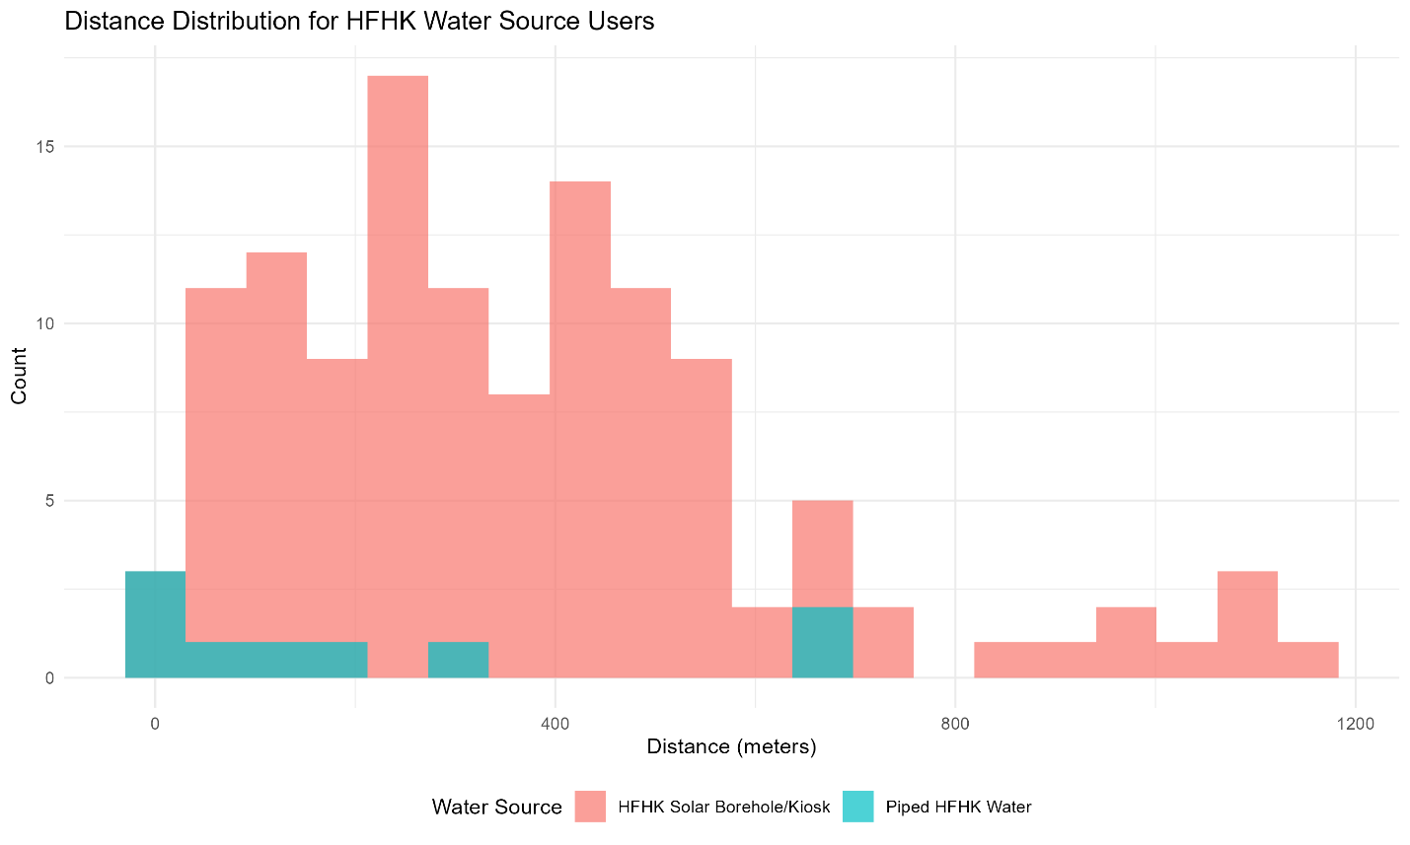
Key Findings
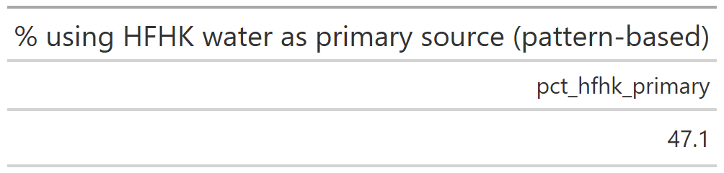
- 154 households use HFHK water sources (Solar Borehole/Kiosk or Piped HFHK Water) with 132(47.1) Solar Borehole/Kiosk and Piped HFHK Water 12(7.9%)
Distance distribution shows a bimodal pattern with clusters around both short (<500m) and medium-long distances (500-1000m)
- 73.4% of HFHK users travel less than 500 meters to their water source
- 26.6% travel between 500 meters and 1 kilometer
- Minimal long-distance travel (>1km) among HFHK users
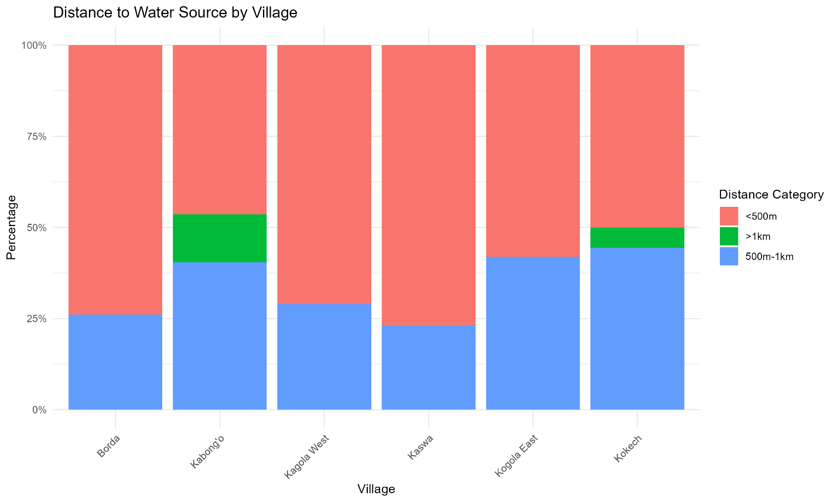
Interpretation
The HFHK infrastructure has successfully provided relatively proximate water access for most users, though a significant minority still face moderate distance challenges. The bimodal distribution suggests some users may be located at the periphery of service areas.

B) Non-HFHK Water Source Users Analysis
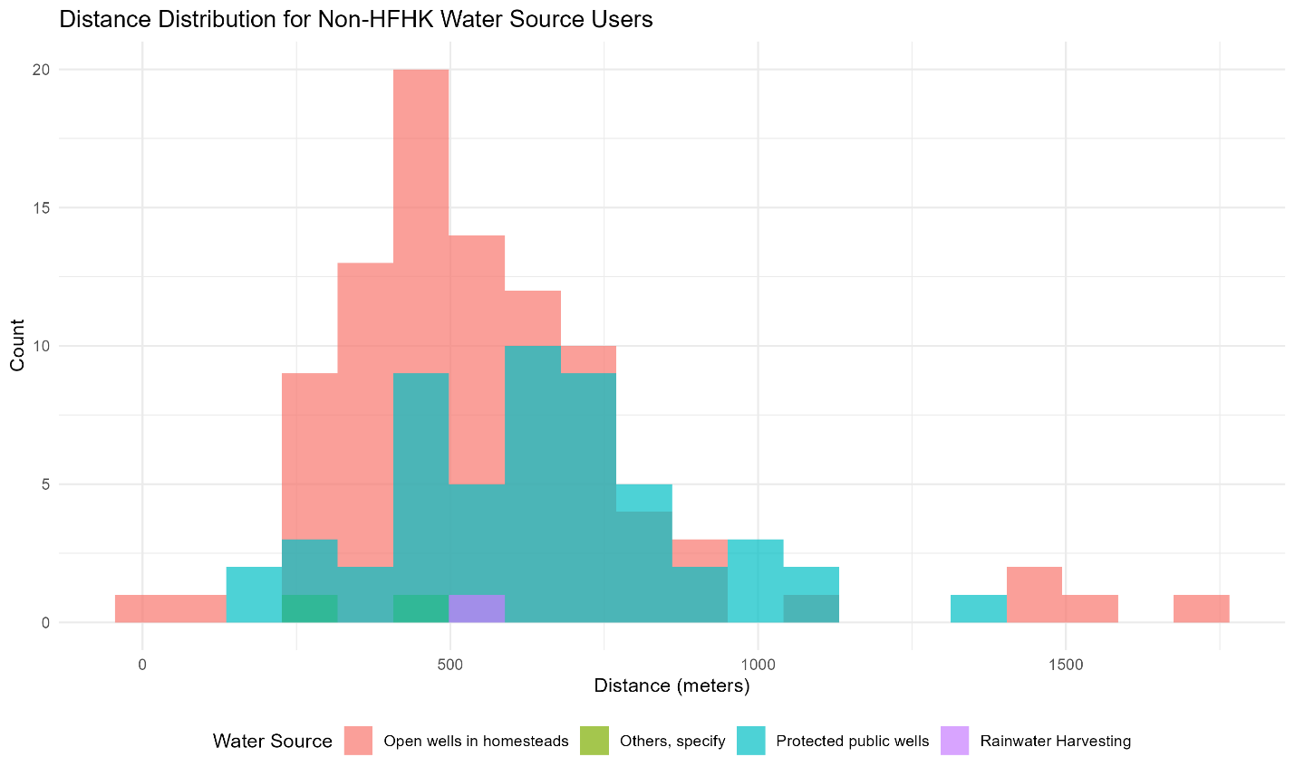
Key Findings
- 126 households rely on non-HFHK sources (Open wells, Protected wells, Rainwater, Other)
- Distance distribution shows wider variability with more extreme values
- Significant long-distance travel observed, with some households traveling over 1.5km
- Open wells and protected public wells show similar distance patterns
- Higher distance burden compared to HFHK users
Interpretation
Non-HFHK users experience substantially greater water-fetching burdens, with many traveling considerably longer distances. This highlights the accessibility gap between HFHK-served and non-served households.

C) Distance to Water Source by Village
Percentage of Households by Distance Category
Village | <500m | 500m-1km | >1km
Borda | 73.9% | 26.1% | 0%
Kabong'o | 46.4% | 40.5% | 13.1%
Kagola West | 71.0% | 29.0% | 0%
Kaswa | 76.9% | 23.1% | 0%
Kogola East | 58.1% | 41.9% | 0%
Kokech | 50.0% | 44.4% | 5.6%
Interpretation:
- Kaswa shows the best proximity outcomes with 76.9% of households within 500m
- Kabong'o has the most challenging situation with 13.1% traveling >1km and only 46.4% within 500m
- Kokech shows moderate performance with half the population within 500m but significant medium-distance travel
- No village has achieved universal access within 500m, indicating room for improvement

D) Water Source Distribution by Village
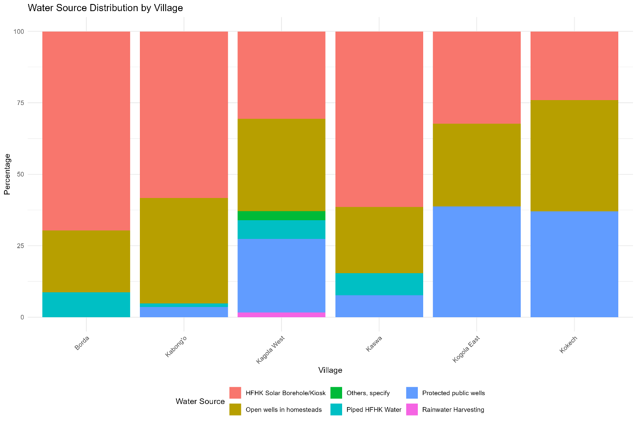
HFHK Adoption Rates
- Borda: 78.3% (Highest adoption)
- Kabong'o: 59.5%
- Kaswa: 69.2%
- Kogola East: 32.3% (Lowest adoption)
- Kokech: 24.1% (Second lowest)
- Kagola West: 37.1%
Traditional Source Dependence
- Kokech: 75.9% still use traditional sources (Open wells + Protected wells)
- Kogola East: 67.7% use traditional sources
- Kagola West: 61.3% use traditional sources
- Kabong'o: 40.5% use traditional sources
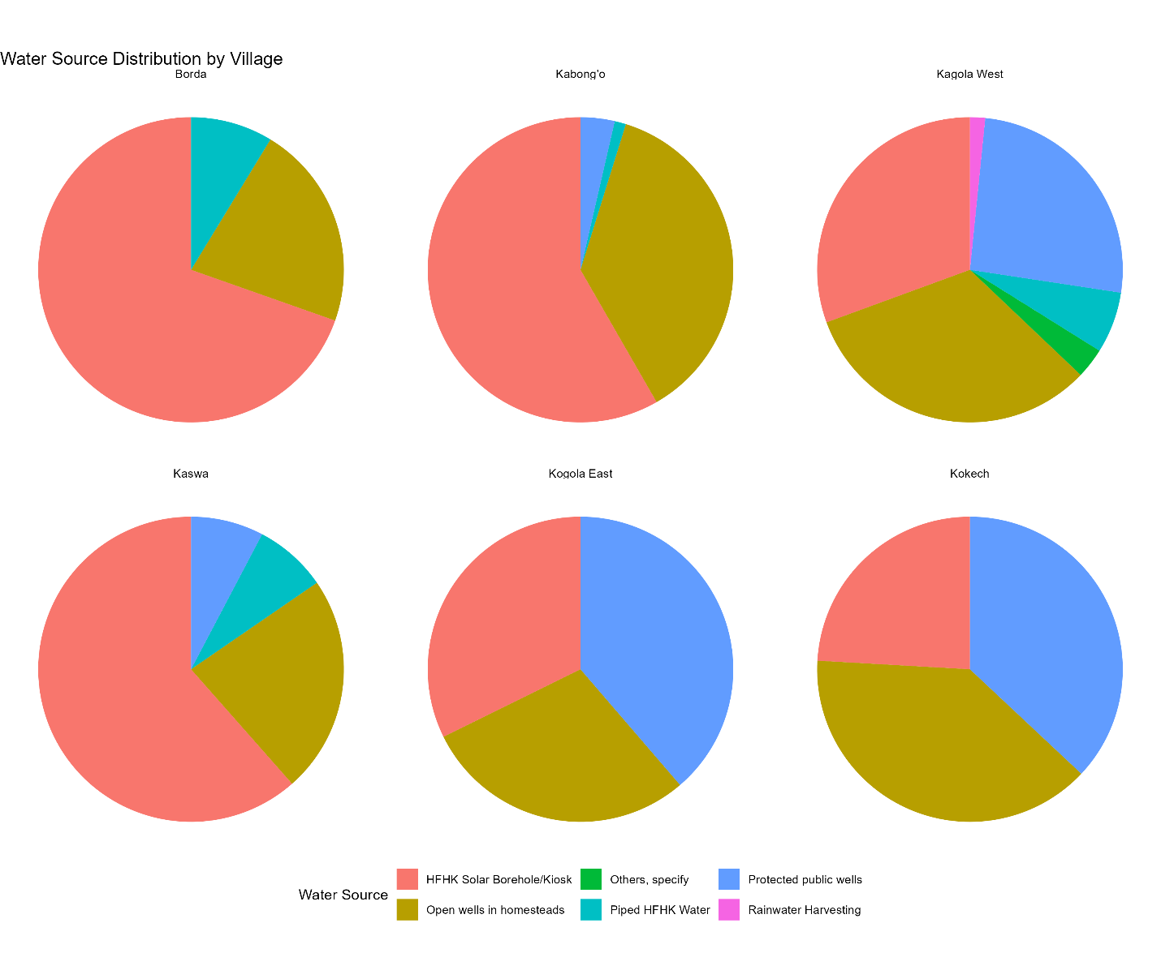
Interpretation
There is significant variation in HFHK adoption across villages. Borda shows excellent penetration while Kokech and Kogola East lag significantly. The persistence of traditional water sources, particularly in Kokech (75.9%), suggests either accessibility challenges, preference factors, or service coverage gaps in these areas.

Recommendations
- Targeted Infrastructure Expansion - Focus on villages with low HFHK adoption (Kokech, Kogola East) and those with significant long-distance travel (Kabong'o)
- Distance Reduction Initiatives - Implement additional water points in peripheral areas of villages showing bimodal distance distributions
- Traditional Source Improvement - For villages with high traditional source dependence, consider upgrading existing infrastructure while expanding HFHK coverage

Village-Specific Strategies
  - Kabong'o - Address the 13.1% traveling >1km
  - Kokech & Kogola East - Increase HFHK adoption through community engagement and infrastructure expansion
  - Kagola West - Balance between HFHK expansion and traditional source maintenance given the mixed usage pattern
This analysis demonstrates that while HFHK interventions have significantly improved water access, substantial disparities remain across villages that require targeted interventions to ensure equitable water access for all communities.

